Science Research Project
Parent Information Sheet

What is the Science Research Expo?
The AACPS Innovators of Science and Engineering Challenge includes a Science Research Expo where students can showcase their personal explorations in science and engineering. This event is a competition that invites students to go through the steps of the scientific method and conduct scientific experiments like real scientists do. Science research projects are an opportunity for children to conduct research on topics they find interesting.
Why should my child compete?
Science research projects are a great way to get students to become life-long lovers of science. They are fun for children to complete and the whole family can get involved in helping and watching the results of the experiments. There are many awards to be won if your child’s project is selected to compete in the AACPS Innovators Research Expo.
What will my child need for the project?
It depends on your child’s interests. Each project will need different materials. Many projects require just a few materials or none at all. The most important part of a science research project is that the student carefully makes observations in order to answer a research question. Once the observations from the experiment tests are gathered, they will need to be displayed on a tri-fold board. Tri-fold boards can be purchased for between $1-$4 at Wal-Mart, Target, or the Dollar Tree store.
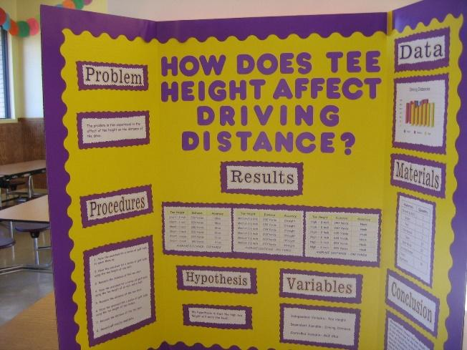
Blank Tri-Fold Project Board Finished Science Fair Project Tri-Fold Board

Steps for Completing a Science Research Project
STEP 1: Pick a Research Question
What is a research question?
Science research projects answer a question. The questions usually start with words like Which, What, When, Where, Why, or How. Good projects are easily researched using just simple things from around the house. Good projects are not too complicated or dangerous. The topic must be something that can be tested and measured by a child. Here are some examples of good research questions:
- Which brand of nail polish lasts the longest without chipping?
- Does water expand when it is heated or frozen?
- What type of light is best for growing seeds? (lightbulb or natural light)
- Which type of bag (paper, clear plastic, white plastic) keeps fruit fresh the longest?
- Which brand of laundry detergent gets stains out the best?

Here are some examples of questions that do NOT make good science research projects:
- Which planet is the largest? (Too simple. No experiment is needed to answer this.)
- What is the life cycle of a butterfly? (This is not something that is an experiment which is measured. It’s just an observation.)
- Which grade of gasoline burns the hottest? (Too complicated. You would need a real science lab to test this accurately, and it’s also dangerous.)
- How many times can I pinch my brother before he tattles to mom? (You can’t do any project that hurts other people.)

Before you select your project, please know that you CANNOT use ANY of the following in the AACPS Science Research Expo:
- Weapons of any kind
- Animals
- Medicine or drugs
- Alcohol
- Tobacco products
- Mold or bacteria
- Harsh chemicals (including bleach, liquid nitrogen, dry ice, etc.)
- Blood or human tissue

When your child has picked his or her research question, a safety form must be filled out and turned in to your child’s teacher. The teacher will return the form if changes need to be made. A copy of that form is included in this packet. A Spanish version is included as a reference, but the safety form must be submitted on the English form.

Step 2: Gather the Necessary Materials and Plan the Experiment
Once the research project has been approved by the teacher, think about what materials will be needed. Talk to your child about how he or she wants to do the experiment. The experiment should be a fair test of the research question. For example, if your child was trying to determine which laundry detergent would get stains out the best, the same type of clothing item should be used for each test. The test would not be fair if one test was done on silk and another was done on cotton. Also, the same amount of detergent would need to be used in each test. The stain would need to be the same on all tests, too. It would not be fair to test one laundry detergent on a grass stain and another detergent on a spaghetti sauce stain.
Materials for the experiment can be purchased or gathered by you, or some basic materials may be available at the school. Take the cost of the materials into consideration before planning the experiment with your child.

Step 3: Make a Hypothesis
Before actually doing the experiment, your child needs to first decide what he or she thinks will happen during the experiment. For example, if your child is testing which type of bag will keep fruit fresh the longest, he or she must decide BEFORE doing the experiment which bag they think will work best and write this down. This prediction is called a “hypothesis” in science.

Step 4: Do the Experiment
Monitor and help your child as they conduct the experiment they planned. Any experiment done should be done three times. This is how real scientists verify that the results are true and reliable. So if your child wants to test which laundry detergent gets stains out the best, select 3 brands of laundry detergent, create 3 similar stains on an old t-shirt, and wash them. Record which stain was cleaned best. Then do the exact same experiment 2 more times to be sure the results are the same each time.
If the results are not the same each time, that is okay. Your child can write ideas about why the results were different each time at the end of the experiment.
It’s a good idea to take pictures of the project as your child is doing it. That way there are pictures of the project to put on the tri-fold board
Step 5: Look at the Results
Look at the results of the experiment. Your child should think about what the results mean and whether his or her hypothesis was correct or incorrect. It’s okay if your child’s hypothesis was wrong. Scientists make incorrect hypotheses all the time. Having an incorrect hypothesis actually shows the child learned something from the experiment, which is good.
Your child will need to create a graph, table, or other visual that shows the results of the experiment. This visual will need to be posted on the tri-fold board.
Next, your child will need to write a written statement about the results he or she got from the experiments. This written portion will need to be specific.
Step 6: Write a Conclusion
The conclusion needs to have the following things in it:
- A summary of the experiment
- A summary of the results
- Whether or not the results proved the hypothesis true or false
- How these scientific findings might be helpful to people
- Any places in the project where possible mistakes were made.

Step 7: Make the Tri-Fold Board
The tri-fold board should be neat and pleasing to look at. It should have the following things on it:
- A title for the project
- The research question
- The hypothesis
- The materials used
- A step-by-step set of directions that tell how the experiment was conducted
- A chart, graph, or table that shows the results
- The written analysis of the results
- The conclusion that summarizes the whole project
- Pictures of the project
Written portions of the trifold board should be typed up on a computer and printed rather than handwritten if possible.

Information about the AACPS Innovators of Science and Engineering Challenge can be found at
https://www.aacps.org/Page/1427.

If you have any further questions, please contact the AACPS Office of Science.
Kate Dobrzenski (410) 266-3718
kdobrzenski@aacps.org
Valerie Wesner (410) 222-5451
vwesner@aacps.org

